The staking experience is a straight forward process that anyone can follow.

It will require only a few simple steps to start yielding TWMT and building your watch.

* Desktop user can only stake via Metamask extension + wallet
* Mobile user can only stake via Metamask or coinbase Dapp Browsers. Recommended to stake via desktop for an optimum experience.
* User can stake via user hard wallet (ledger/trezor) through metamask.
* User can stake up to 50 NFT’s in a single transaction. User can make as many TWM as user would like.
* When staked user NFT’s will enter the staking contract and leave user wallet. User will not be able to see them on Opensea in user wallet.
* If user want to unstake, user can do this at any point. When user unstake user NFT’s will reappear in user wallet on Opensea.
* When user TWMs are in the staking contract, user will not be able to trade them

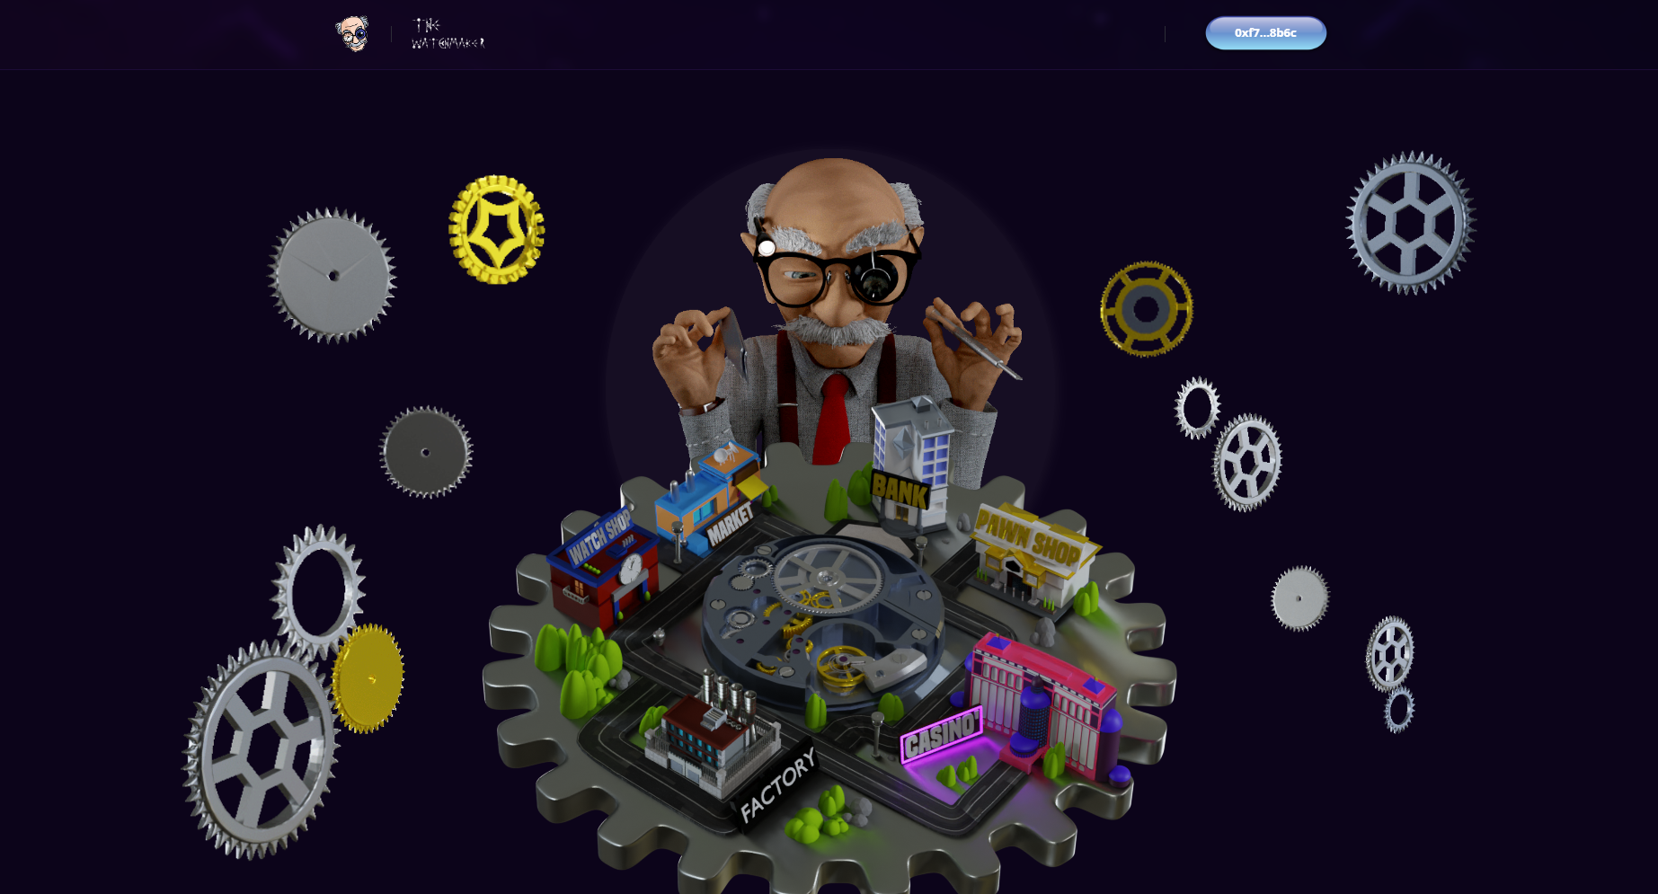

**How does it work?**

Staking from Desktop is the most optimum experience, as user can stake via the watch map.

However, if user wanted to stake via mobile, user can do this through the Metamask or Coinbase Dapp browser.

What do user need to prepare:

1. Metamask installed on user’s browser or mobile
2. User’s TWM in user’s wallet ready to go
3. Enough ETH for the staking gas fees
4. User’s diamond hands for the staking

**Staking TWM Workflow**

1. User visits the website.
2. On the map, click the “BANK” building. This should be green on hover.
3. (red on hover means user cannot access it). User can also access staking by clicking “STAKE” in the navigation menu.
4. This will open up the staking “Bank” where user can begin user’s staking.
5. When user first enter “BANK”, user will see a message that confirms user have no TWM staked.

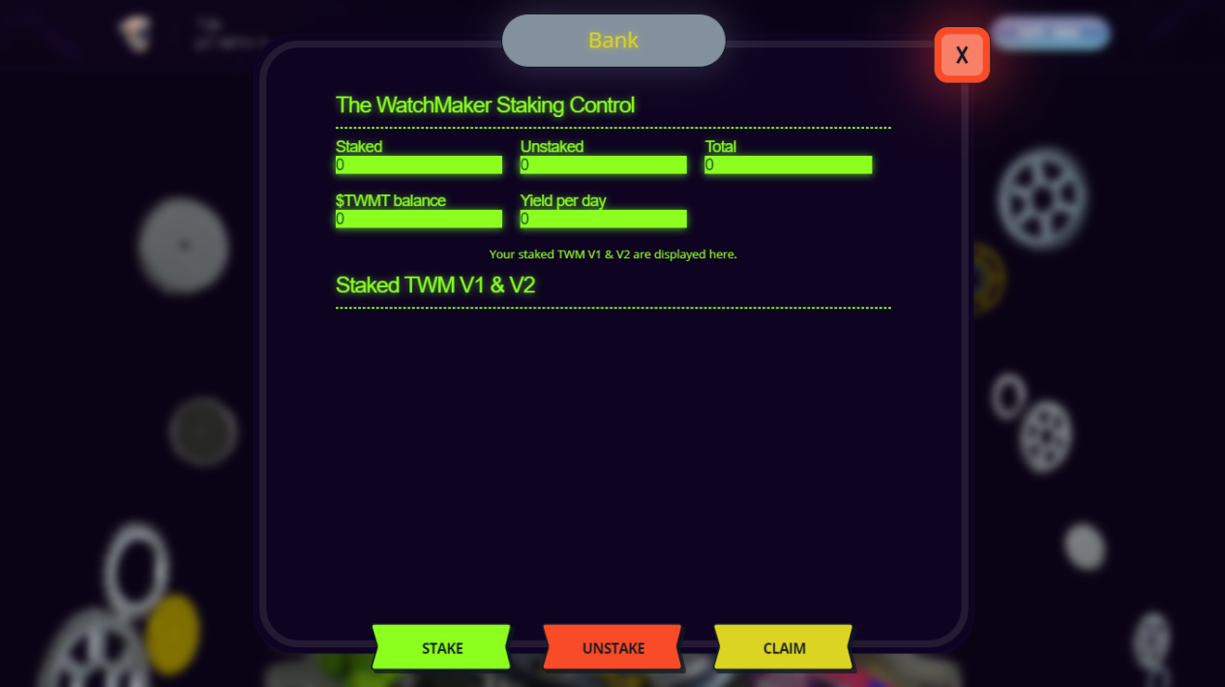

1. From here, click the green “STAKE” button to open up a screen with all user’s available TWM V1 & V2 ready for user’s to commit to the staking.
2. Before user can stake TWM V1 & V2, user will need to “Approve Wallet”. This will kick the user out to Metamask where the user can authorise your wallet. Once completed, user can continue to select user’s TWM V1 & V2 to join the staking.

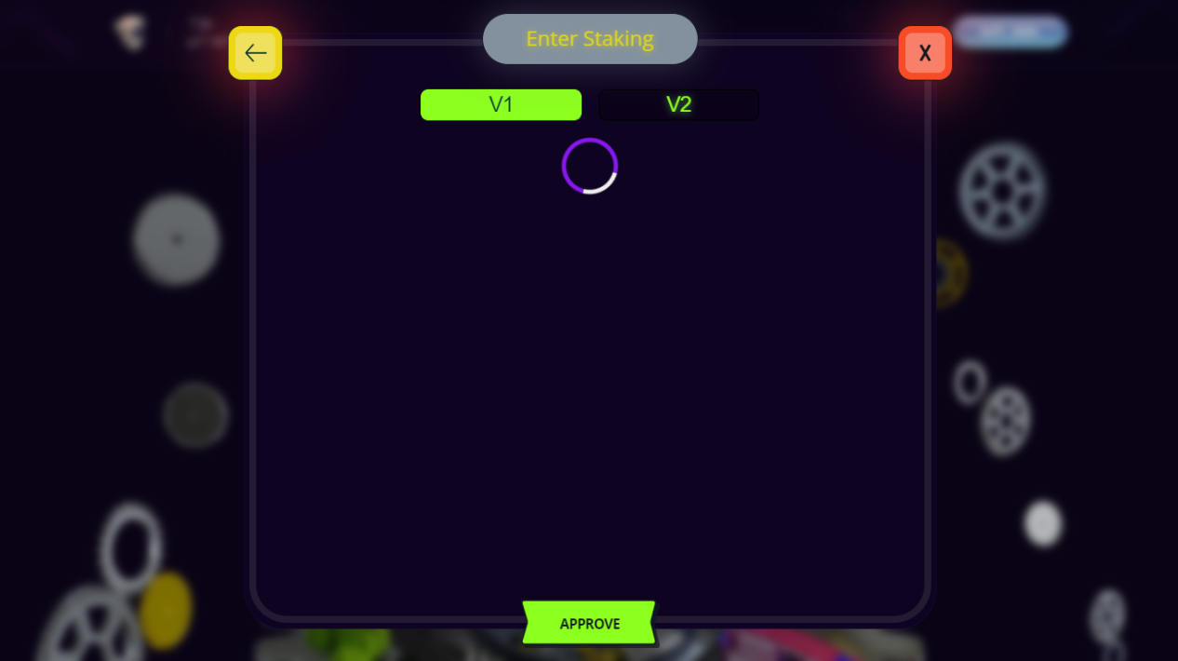

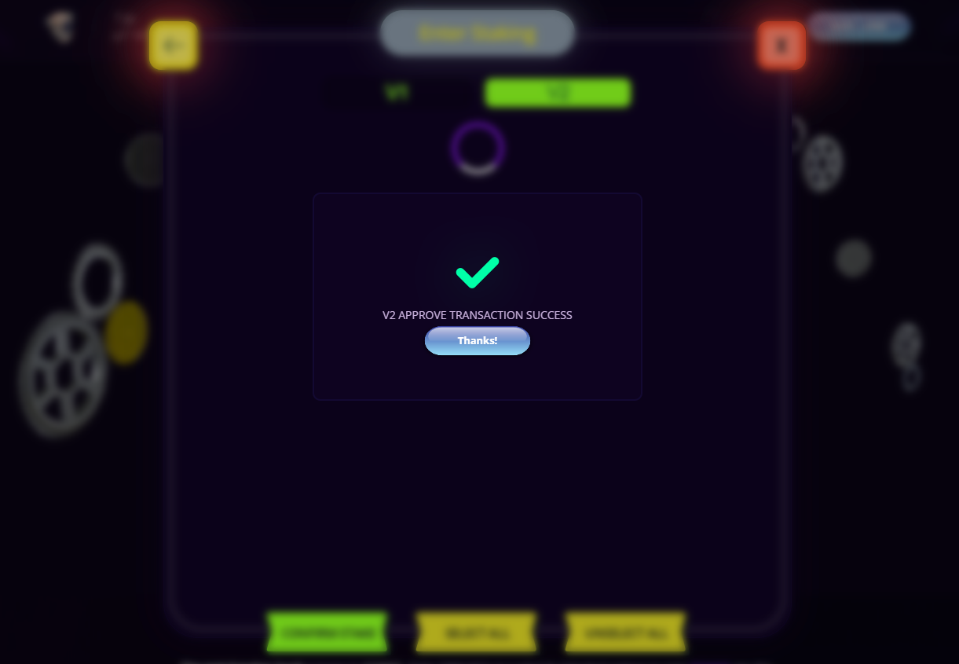

1. Select the TWM user are looking to stake. User will set the circle icon turn green when user have selected them. Once selected press “Confirm Stake”.
2. This will open up Metamask to confirm the transaction & once completed user’s TWM will be staked & yield TWMT

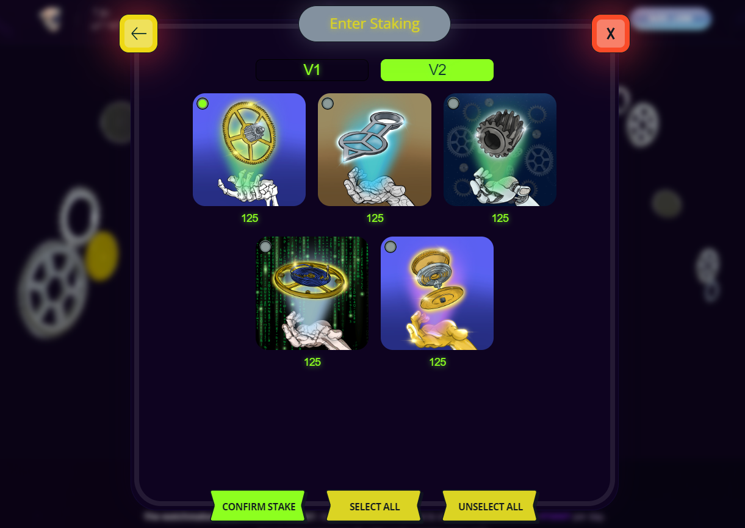

1. Once user’s TWM are staked (user will see a confirmation message) user will see user’s TWM on “Bank” page.
2. On here user will also see user total in TWMT balance, daily yield (accumulated from all staked characters) & user’s staking balance.

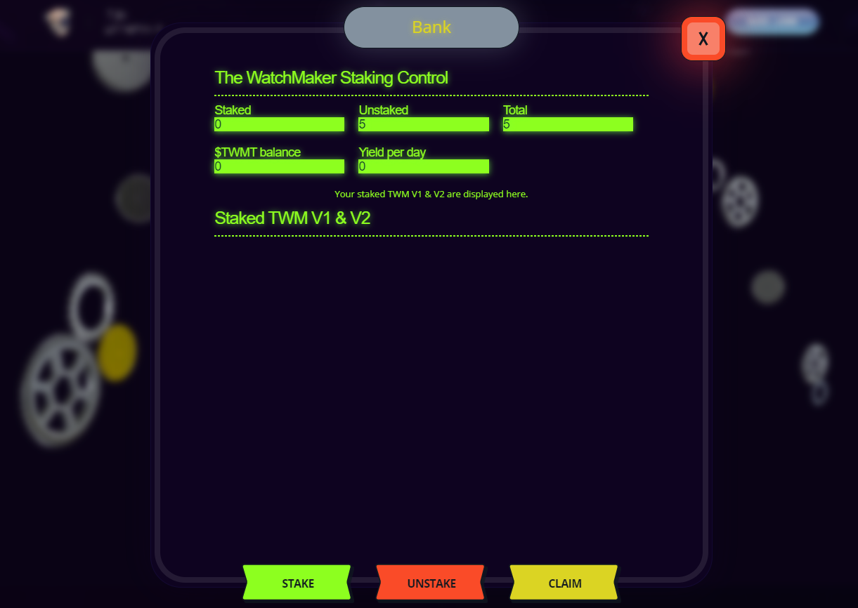

1. It’s important to note, user will no longer see user’s NFTs in user’s wallet on OpenSea, they will be in staking contracts wallet. This is due to them being inside the staking contract. This perfectly normal and user is still the owner and the only one who can withdraw them at any time.
2. From here on out, its very simple and user don’t need to do anything but kick back and watch as user’s TWM yield.

**Unstaking TWM Workflow**

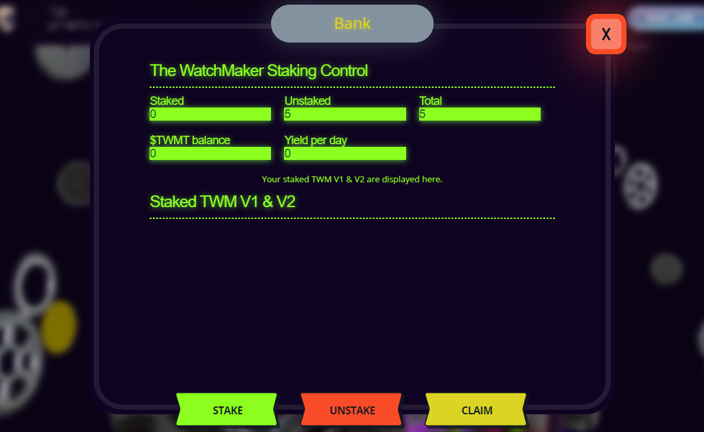

1. Unstaking TWM is just as straight forward as staking them. Navigate to “Bank” and click the red “UNSTAKE” button.
2. Select the TWM user want to leave the bank. User will see a green light on the ones user has selected. Once selected click “Confirm Unstake” and user will be taken to Metamask to confirm unstake.
3. Once this has been done your TWM will no longer be in the staking contract and instead they will be back in user wallet on OpenSea for you to trade.
4. User’s TWMT balance will not go anywhere if user unstake user’s TWM - user will not lose it.

**Claim reward**

1. Navigate to “Bank” and click the red “CLAIM” button.
2. User will see the TWMT Reward Status. Once selected click “Confirm Claim” and user will be taken to Metamask to confirm claim. The Bank keeps 25% of the user coin as a tax to take it out of the world of watchmaking.

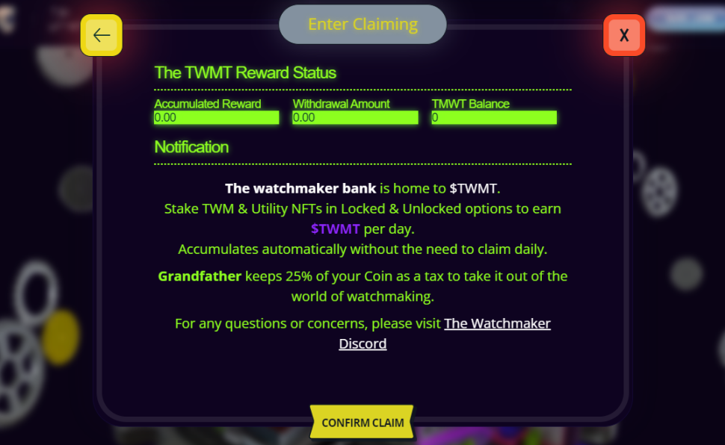

If possible, please add an option for admin to decide how many token give for reward to a user who stake a NFT with particular attribute (for example, NFTs with Inflate Doll attribute in right_hand earn 10%++) or something similar

**Crypto Payment System (New Logic)**

* Deposit logic  
    
  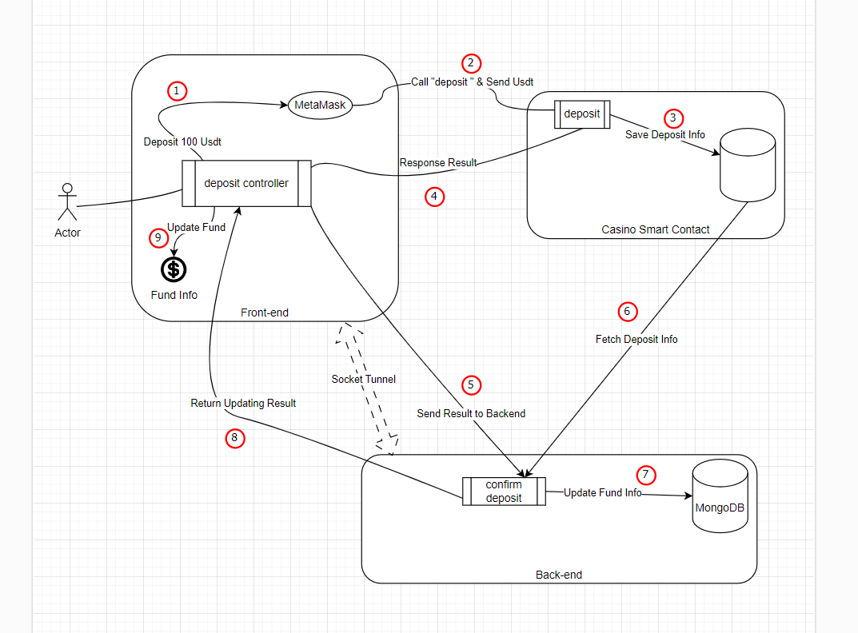
* Withdraw logic  
    
  